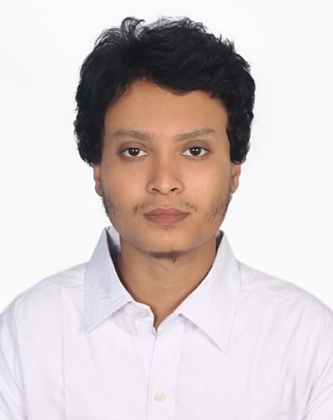

**Md Farhad Hossain**

**Lakshmipur, Chattogram, Bangladesh|** [**mdfarhadhossain37ru@gmail.com|**](mailto:mdfarhadhossain37ru@gmail.com|) **8801728-510359, 8801754-196793**

**CAREER OBJECTIVES**

A scientifically driven Biochemistry and Molecular Biology graduate with hands-on experience in Biochemistry, Microbiology, and Molecular Biology. Proven ability to conduct complex laboratory analyses, particularly in molecular diagnostics and biochemical testing. Passionate about advancing research in pharmaceutical sciences and contributing to quality control measures. Ready to apply a strong foundation in laboratory techniques and research methodologies to support pharmaceutical innovation and ensure product quality.

**EDUCATION**

**University of Rajshahi, Rajshahi, Bangladesh**

**B.Sc. in Biochemistry and Molecular Biology 2021**

**Cumulative GPA: 3.38/4**

**COURSES TAKEN**

**Undergraduate level:**

Biochemistry, Molecular Biology and Genetic Engineering, Biotechnology, Microbiology, Cell Biology, Metabolism, Biotechniques, Protein Technology, Immunology, Oncology, Human Nutrition, Endocrinology, Physiology, Neurochemistry, Clinical & Pharmaceutical Biochemistry, Basic Statistics.

**SKILLS & TECHNIQUES**

|  |  |
| --- | --- |
| * **Biochemistry Skills:** * **Molecular Biology Skills:** * **Microbiology Skills:** | Chromatographic separations, isolation and characterization of biological materials, Titration, TLC, UV spectroscopy, biochemical analysis, electrophoretic techniques, enzyme kinetics, ELISA, gel-electrophoresis  Nucleic acid extraction, qPCR  Microscopy, gram staining, media preparation, bacterial identification |

**EXPERIENCE**

**Internship at Child Health Research Foundation, Bangladesh**

* **Biochemistry Lab: Dr. MR Khan Shishu Hospital & Institute of Child Health** (Biochemical Analysis; Validation, Quality Control and Calibration of the diagnostic machine; ABO blood grouping)
* **Microbiology Lab (WHO’S sentinel lab): Bangladesh Shishu Hospital & Institute** (Media preparation, microbiological analysis of Specimens, antibiotic susceptibility, identification of bacterial pathogen from clinical specimen)
* **Molecular Biology Lab: Child Health Research Foundation Headquarters** ( Nucleic acid extraction and qPCR, Basics of next-generation sequencing)

**PERSONAL** **DETAILS**

Nationality: Bangladeshi

Date of Birth: 18-07-1997

Marital Status: Unmarried

**REFERENCES**

|  |  |  |
| --- | --- | --- |
| [DR. IMTIAJ HASAN](http://rurfid.ru.ac.bd/ru_profile/public/teacher/22306025/profile) Professor Department of Biochemistry & Molecular Biology  University of Rajshahi, Bangladesh  Email: [imtiajbio@ru.ac.bd, hasanimtiaj@yahoo.co.uk](mailto:imtiajbio@ru.ac.bd,%20hasanimtiaj@yahoo.co.uk) | [MD. FARHADUL ISLAM](http://rurfid.ru.ac.bd/ru_profile/public/teacher/22306034/profile) Associate Professor Department of Biochemistry & Molecular Biology  University of Rajshahi, Bangladesh  Email: [farhad_bio83@ru.ac.bd](mailto:farhad_bio83@ru.ac.bd) | [MD. ABDUL AZIZ](http://rurfid.ru.ac.bd/ru_profile/public/teacher/22306032/profile) Associate Professor Department of Biochemistry & Molecular Biology  University of Rajshahi, Bangladesh  Email: [maazizbio@ru.ac.bd, maazizbio@gmail.com](mailto:maazizbio@ru.ac.bd,%20maazizbio@gmail.com) |